PROJECT NAME: M1_PROECTGOAL_UTIL.

CALCULATOR

PROJECT MADE BY “ANCHAL TIWARI”

The project aims to deliver a calculator which can be very useful to Mathematics problems like Addition, Subtraction, Multiplication, Division, Factorial, and Power.

**1.INTRODUCTION:**

I have been assigned a project. I have created a Calculator by using c Language. The name of my project is M1_PROECTGOAL_UTIL.

There is 8 folder in this project which have different file related to my project. I have explained all the things using links as well as a screenshot of my project.

**2.REQUIREMENTS:**

Requirements - As per the template

Design - Using UML tools and Compliant

Test Plan - As per the template

Coding - Based on Learnings

Multi Files Coding

Multi-Platform Compile

Auto Code Documentation using Dioxygen

Code Quality Checks

Raising Self Tickets and Issues

Unit Testing Framework setup and asserts

Compliance

Git repo push/commit

Working Prototype for peer review and testing

Folder Structure

Updated Readme

**3.IMPLEMENTATION:**

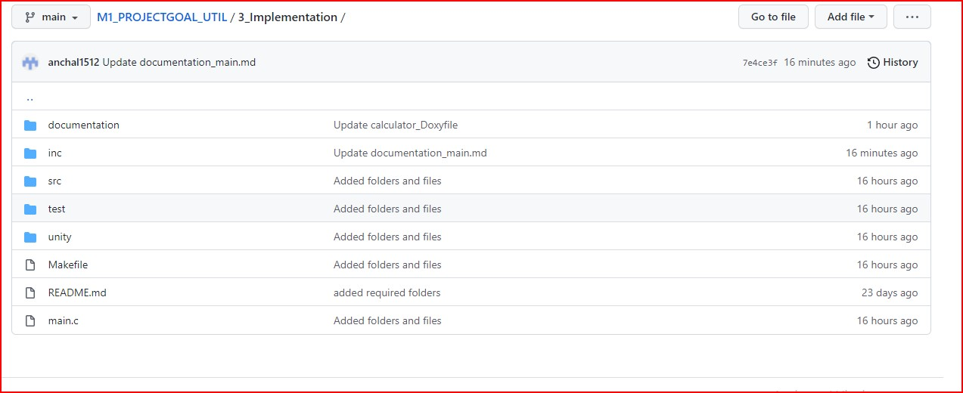

**4.TESTPLANANDOUTPUT:**

**High-level Test Cases:-**

**Low-level Test Cases:-**

**5.IMAGES AND VIDEOS:**

**6.REFERENCES:**

https://gealearn.ltts.com/course/view.php?id=242

https://embeddedinventor.com/doxygen-tutorial-getti

https://web.microsoftstream.com/video/f56e5a55-eab4-409a-bd24-4e162983144e

https://www3.ntu.edu.sg/home/ehchua/programming/cpp/gcc_make.html

https://www.guru99.com/unit-testing-guide.html

https://www.throwtheswitch.org/unity

https://web.microsoftstream.com/video/1cd677ad-bcb0-476a-b57f-9952d253aac0

https://github.com/stepin654321/MiniProject_Template/tree/master/Example_Programs/programming_concpets/calculator

https://github.com/stepin654321/MiniProject_Template/tree/master/Example_Programs/Factorial

https://users.ece.cmu.edu/~koopman/lectures/ece642/16_UnitTest.pdf

https://embetronicx.com/tutorials/unit_testing/unit-testing-in-c-code-coverage/

https://www.tutorialspoint.com/unix_commands/gcov.htm

https://gealearn.ltts.com/mod/page/view.php?id=636

https://vincentcodes.wordpress.com/2018/04/02/debugging-fundamentals/

https://www.youtube.com/watch?v=D8imWEgyS1g&feature=youtu.be

ng-started-using-Doxygen-on-windows/

https://embeddedinventor.com/guide-to-configure-doxygen-to-document-c-source-code-for-beginners/#Doxygen_pages

https://gealearn.ltts.com/mod/page/view.php?id=633

https://gealearn.ltts.com/mod/page/view.php?id=634

https://gealearn.ltts.com/mod/page/view.php?id=604

https://softwareengineering.stackexchange.com/questions/401415/what-are-the-benefits-of-multi-file-programming

https://web.microsoftstream.com/video/9a2b1eba-61a3-4547-8292-374b2eeb5265

https://web.microsoftstream.com/video/f56e5a55-eab4-409a-bd24-4e162983144e

https://www3.ntu.edu.sg/home/ehchua/programming/cpp/gcc_make.html

https://www.guru99.com/unit-testing-guide.html

https://www.throwtheswitch.org/unity

https://web.microsoftstream.com/video/1cd677ad-bcb0-476a-b57f-9952d253aac0

https://github.com/stepin654321/MiniProject_Template/tree/master/Example_Programs/programming_concpets/calculator

https://github.com/stepin654321/MiniProject_Template/tree/master/Example_Programs/Factorial

https://users.ece.cmu.edu/~koopman/lectures/ece642/16_UnitTest.pdf

https://embetronicx.com/tutorials/unit_testing/unit-testing-in-c-code-coverage/

https://www.tutorialspoint.com/unix_commands/gcov.htm

https://gealearn.ltts.com/mod/page/view.php?id=636

https://vincentcodes.wordpress.com/2018/04/02/debugging-fundamentals/

https://www.youtube.com/watch?v=D8imWEgyS1g&feature=youtu.be